# Heightmap

Before we can generate a heightmap, we first need a grid of triangles. The problem is rendering each triangle for itself is pretty performance intensive. It’s better to render all triangles oft the grid with one “triangle strip”.

**How to generate a grid with one TRIANGLE_STRIP**

If we consider a n*n-matrix we do have (n+1)^2 vertice points.  
In a short 3x3 example we will show how this algorithm works:

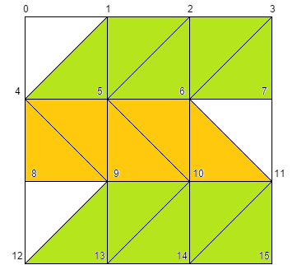

In each row we switch the direction of the diagonal lines, because otherwise many indices would be used multiple times and it wouldn’t end up in such a nice index distribution:

0, 4, 1, 5, 2, 6, 3, 7, 11, 6, 10, 5, 9, 4, 8, 12, 9, 13, 10, 14, 11, 15

At the transition from one row to another (what means the diagonal direction changes) there are no real triangles (as you can see at the indices 3,7,11 or at 4,8,12). There no triangles are rendered, but most of the time you won’t even notice that they are missing.

To form code out of these indices we need to find the pattern in there. Rearranging these indices helps a lot:

0,  
4, 1, 5, 2, 6, 3, 7,  
11, 6, 10, 5, 9, 4, 8,  
12, 9, 13, 10, 14, 11, 15

The resulting algorithm (in pseudocode) looks like this:

Add 0 to the list  
Iterating through each row   
 if (row is odd)  
 start at column 0  
 add the bottom index (at column 0) and then the top index (of the next column) to   
 the list in an alternating manner going to the right until the right side is reached

Else (row is even)  
 start at the last column  
 add the bottom index (from the last column) and then the top index (from the   
 previous column) to the list in an alternating manner going to the left until the left   
 side is reached

**Shaders of the heightmap**

For a heightmap the y-values are the important ones, because these create the high “mountains” of the map. To create the y-values from an “black/white”-image we first give the vertex shader the image via an uniform of type sampler2D.  
  
With the function “texture2D(imageTexture, vec2(x, y)) you get the color value of this specific point of the image texture. We use this color as the y-position (instead of the attribute “a_position.y”). With this, we have a vector, where the y-coordinate depends on the color of the texture image.  
  
To give the heightmap a nice texture we do the same as before. Give the fragment shader an image with an uniform of type sampler2D and use get the right color with the function “texture2D(…)”.